**CSE326**

**CSE Project**

**Project Title:**

**Income Tax Department of India**

Project No. 06

(Final Project Report of CSE 326 Project)

Section: K19GK

**Submitted To: Manu Bali**

**D.O.S**: 12th April 2020

**Group Members:**

|  |  |  |
| --- | --- | --- |
| Name | Roll no. | Registration No. |
| Kisalaya Kishan | 15 | 11908514 |
| Raja Shekhar Reddy | 16 | 11908537 |
| Rhythm Chouhan | 17 | 11908380 |

**ACKNOWLEDGEMENT**

We would like to express our Special thanks of Gratitude to our University as well as our CSE Faculty **Manu Bali** ma’am who gave us this opportunity to work on the project to “**Design a Website of Income Tax Department of India”** which Also helped us in learning and developing skill in HTML,CSS and Java Script.

*Finally, I would like to thank my friends who helped me a lot in finishing this topic within a limited time.*

Thanks to All!

***

Final Project Report On

Income Tax Department

of India Website

Introduction

***Overview About the Agency:***

The Income Tax Department is a government agency undertaking direct tax collection of the government of India. It functions under the Department of revenue of the ministry of finance. Main responsibility of IT department is to enforce various direct laws and to collect revenue for government of India. Its headquarter is in north block, secretariat building, New Delhi. The government imposes a tax on taxable income of all persons who are individuals, companies, firms, body of individuals, local authority and any other artificial juridical person. Income Tax is a key source of funds that the government uses to fund its activities and serve the public. The Income Tax Department is the biggest revenue mobilizer for the government.

About Our Project:

The “Income Tax Department of India Website” has been developed to override the problems prevailing in the practicing manual system. The website is supported to eliminate and, in some cases, reduce the hardship faced by this existing system. Moreover, this system is designed for the particular need of the agency to carry out operations in a smooth and effective manner. No formal knowledge is required for user to access this webpage. Thus, by this all it proves it is user friendly and fast management system, as described above, can lead to error free, secure, reliable and effective management system. It can assist the user to concentrate on record keeping. Thus, it will help organization in better utilization of resources.

The purpose of Income Tax Website is to automate the existing manual system by the help of computerized equipment and full-fledged, fulfilling their requirements, so that their valuable data/information can be stored for a longer period with easy accessing and manipulation of the same.

Describing HTML Code of Our Website:

The website consists the logo of Income Tax Department of India at the top left corner at the navigation panel. In the navigation panel we have 5 elements About us, Feedback, Contact, Link Aadhar, Login, Sign up.

We started building this website by firstly creating our index page by naming it as index.html, we also created a .css file for styling our index page and that css file is linked to the index tag using <link> tag. All the styling for the index page has been done on the CSS file.

We have created this navigation bar by creating an unordered list and then styling them using CSS. Firstly, I have taken a <nav> tag given it a class= navigation. Then I have taken a <div> tag with class= “row clear fix” then we have inserted the logo using <img> tag and given it class = logo. Then we have created the navigation bar elements. The navigation elements can be accessed by clicking on them: login page, sign up page, Link Aadhar page are linked externally. We code those html pages and we have used internal CSS for them. Coming to our index page, so after the navigation bar we have added a space for some important announcements, we have used marquee tool to style the text inside the announcements box. We have also used some colour changing text effects to highlight the texts.

Below important announcement panel we have three different sections Login Box, News & Updates and Quick Links. Login section gives user an easy access for login right form the index page. In the login section we have also provided the option for sign up and below these buttons there is an option of forgot password in case if a user forgets her/his password he can change the password and regain the access of his account.

Then beside login section there we have News & Updates section that will provide the daily updates regarding income tax return and related issues. Then to the right of news & Update section we have Quick Link section: in which we have provided five different options like: Link Aadhar, Instant e-PAN, ITR status, Submit Form and Profile.

Functionalities provided By Income Tax department of India website as follows:

* Provides Recent News and updates regarding Income Tax return or related topics.
* It tracks all the previous income tax returns of a user from their account.
* Provides the facility to link Aadhar card.
* Provides the facility to apply for e-PAN card and to get the e-PAN instantly.
* Provides the facility to check your ITR status.
* Provides the facility to submit forms.
* A separate section for Notice is there on the website.

Flow Chart of Our Website:

Home Page

Feedback

Profile

Instant- e-PAN

Link Aadhar

Login /Sign up Page

Login

Sign up

Modules of Income Tax Department Website:

* ITR Status: used for managing ITR details filed by the user.
* Login Module: Used for managing the login details of user.
* User module: Used for managing details of users.
* Feedback module: Used for managing the feedback by the users.
* Sign Up Module: Used for registering user on the website.
* Link Aadhar Module: Used for linking Aadhar to PAN.

Screenshots of Our Website:

Home Page:

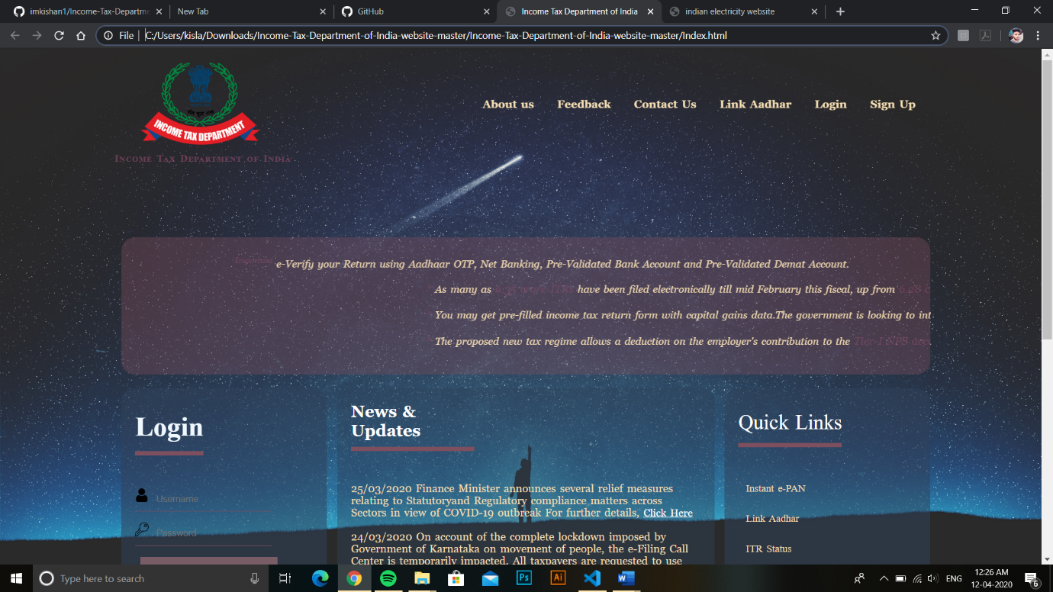

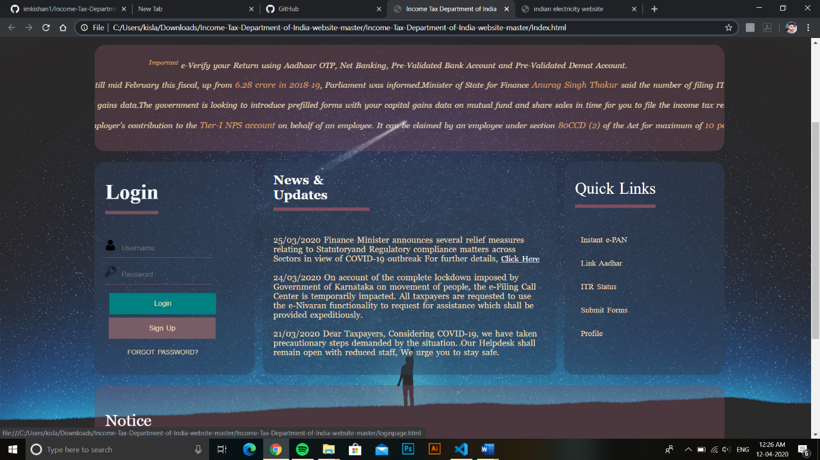

Login Page:

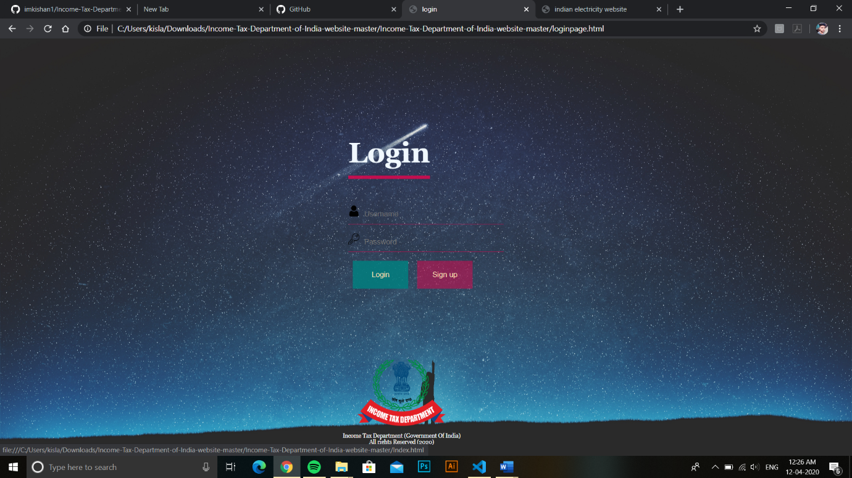

Link Aadhar Page:

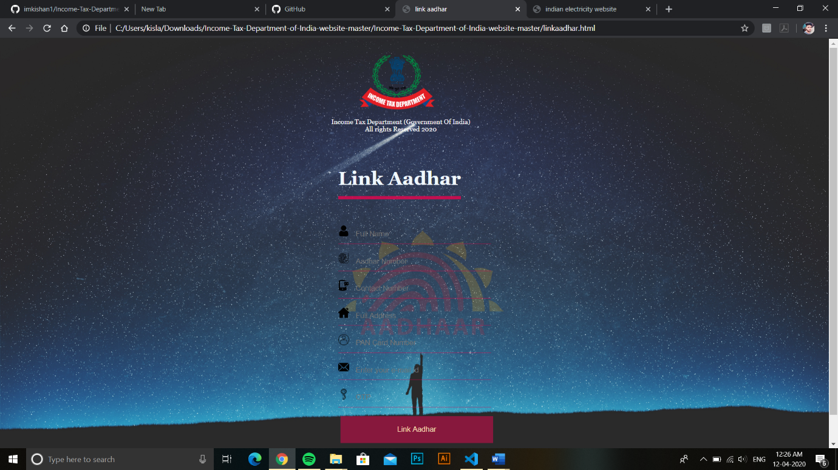

Group member’s role in this project:

* Kisalaya Kishan (11908514): Has designed the website and has done all the HTML coding of Index Page along with its styling and Link Aadhar page. Prepared synopsis of project.
* Raja Shekhar Reddy (11908537): Has Designed Login page, Sign up page. Helped in preparing project report.
* Rhythm Chouhan (11908380): Has done all the CSS work. All the styling of the external pages (i.e. login pages, sign up pages Link Aadhar page). Helped in preparing project report.